**Cloud Computing and Internet of Things - Coursework**

Level 5 Self-Driving System Aided with Vehicle Network and Cloud Service

Sino-British Collaborative Programme, Oxford Brookes University & Chengdu University of Technology



Semester 2, 5.17, 2024

Table of Contents

1. Introduction (Joint Section) 5

2. Sensing system on Vehicle (202018010212) 6

3. Cloud Solution (202018010212) 14

4. Data Collection and Usage (202018010212) 16

5. Roadside Units (RSU) (202018010110) 19

6. V2V & V2I Communication (202018010110) 20

7. Data Security (202018010110) 22

8. Conclusion (Joint Section) 25

9. Work Management (Joint Seciont) 26

List of Figures

Figure 1: Sensors Position on Auto-vehicle 7

Figure 2: Quad-Camera Above and Front view 7

Figure 3: Camara View Area 8

Figure 4: Audio Receiver 8

Figure 5: a) and b) display the RegNet block 1 and 2 9

Figure 6: RegNet STEM Block 9

Figure 7: Stages of RegNet 9

Figure 8: The body and overview structure of RegNet 10

Figure 9：Bi-directional Feature Pyramid Network Concept Overview 10

Figure 10: Combined Neural Network for object detection of auto-driving (RB-Block) 11

Figure 11: Examples of 2D-BEV to 3D-BEV(Occupancy Volume) 11

Figure 12: Pixel depth estimation 12

Figure 13: NeRF 3D Reconstruction Example 12

Figure 14: Audio Process within Sensing System 12

Figure 15: Transformer Decision Making 13

Figure 16: Overall Neural Network of Sensing System (AADNN) 13

Figure 17: Cloud Solution Provides Services 14

Figure 18: Cloud Solution Function Provider 14

Figure 19: Unified Data Collection 16

Figure 20: MapReduce Procedure for Data Aggregation 17

Figure 21: Airsim, opensource simulation provided by Microsoft 17

Figure 22: Model Statistical Training Process 18

Figure 23: Simulation Basic Logic 18

Figure 24: Precise Construction based on specific information of vehicle 18

Figure 25**:** RSU device of ZTE 19

Figure 26**:** Road network diagram 20

Figure 27**:** V2X model 21

Figure 28**:** Perception for Autonomous Vehicles at Intersections 21

Figure 29: Data preprocessing 23

Figure 30**:** Random Forest 24

Figure 31**:** Overall security system architecture 24

**List of Tables**

Table 1: Comparison between popular sensors 7

Table 2: Work Management 27

## Introduction (Joint Section)

While autonomous vehicles have made strides in recent years, achieving Level 5 autonomy remains a challenge. To bridge the gap, this report introduces a novel approach inspired by human driving perception and behaviors. By prioritizing visual inputs and leveraging received audio as support, the proposed system aims at intimating and expand human driving capabilities. System comprises multiple neural networks working codependently to achieve SLAM (Simultaneous Localization and Mapping), incorporate with BDS (BeiDou Nagivation System) as inbuilt map navigation, Ali Cloud solutions and C-V2X protocol for enhanced vehicle network communication, the self-driving system theoretically enables fully autonomous navigation. Furthermore, data security is guaranteed through secure data communication before and during the transmission using encryption algorithm and TLS/SSL protocol respectively, with further threats detection based on signature and anomaly of vehicle system.

## Sensing system on Vehicle (202018010212)

This approach is built on the idea of emulating and expanding human-driving for level 5 autonomy. A comparative investigation of three prominent sensors in Table 1 reveals that cameras outperform others in scenarios identification and information providing. Furthermore, technical developments could allow cameras to overcome weather constraints and improve SLAM accuracy. As a result, the sensing system is mainly vision-based, with audio and inertial measurement unit (IMU) as supporting components.

|  |  |  |  |  |
| --- | --- | --- | --- | --- |
| Sensor | Advantages | Drawbacks | Operations | Boundary Condition |
| **LiDAR**  [1] | -Provides precise 3D  cloud data | -Impaired performance in  adverse  weather | -Estimation of  distances between objects | -Highly Relies on high resolution  GPS for accurate positioning |
| -High accurate  object detection | -Limited detection range |  | -Vulnerable from  signal interference |
| -Effective for  map and  Localization | -Expensive |  | -Decrease in  performance of  urban dense  environment |
| -Low susceptibility | -Limited at  scenario  perception |  |  |
| **MMW-**  **Radar** [2] | -Long distance | -Low  resolution for  accuracy | -Millimeter wave  Signal transmission and  detects reflections | -All weather  resistance |
| -Weather resistance | -Complex logic in information  handling |  | -Struggles of  object classification |
| -Less performance degradation through time | -Limited in  precise object  detection |  |  |
|  | -Vulnerable at  scenario  perception |  |  |
| **Camera** [3] | -Cost efficient | -Degradation in  performance with dim light | -Capture visual  information of  surroundings | -Experience reflection from  certain surface |
| -Direct and  high resolution  visual  information | -Normally  limited to  perception in  depth |  | -Non-resistance to  extreme weather  (High density of  fog, Snowstorm) |
| -Adequate in  information providing | -Vulnerable to  image noises |  |  |
| -Support scene  Recognition  (e.g: Stop at  traffic light) |  |  |  |

Table 1: Comparison between popular sensors

* 1. **Sensors Design**

The sensing system includes eight monocular-wide-angle cameras, two quad-wide-angle-Stereo cameras for depth-estimation-information capturing[4], and with thermal and infrared equipped for weather and low-lighting resistance [5], four audio receivers, and IMUs on four wheels. This allows full visual information collecting, sound processing and direct motion detection for making decisions. And inbuilt BDS is used for accurate navigation. Figure1 to 4 display the design.

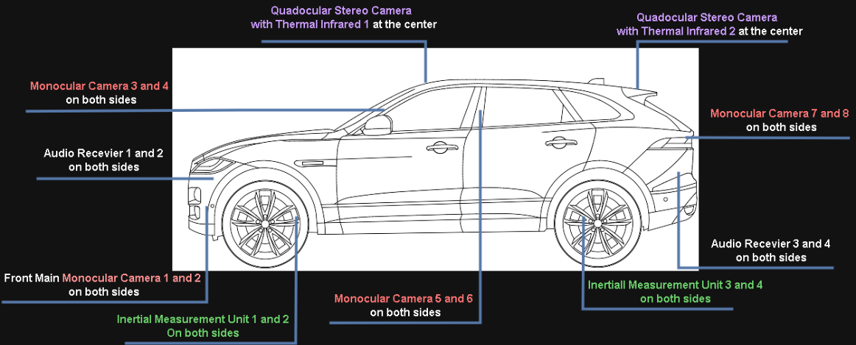

Figure 1: Sensors Position on Auto-vehicle

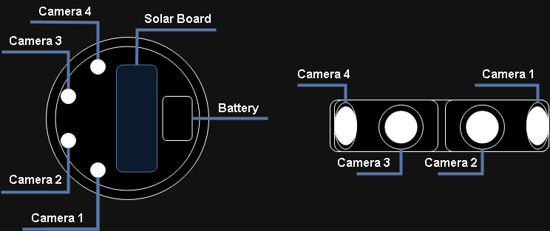

Figure 2: Quad-Camera Above and Front view

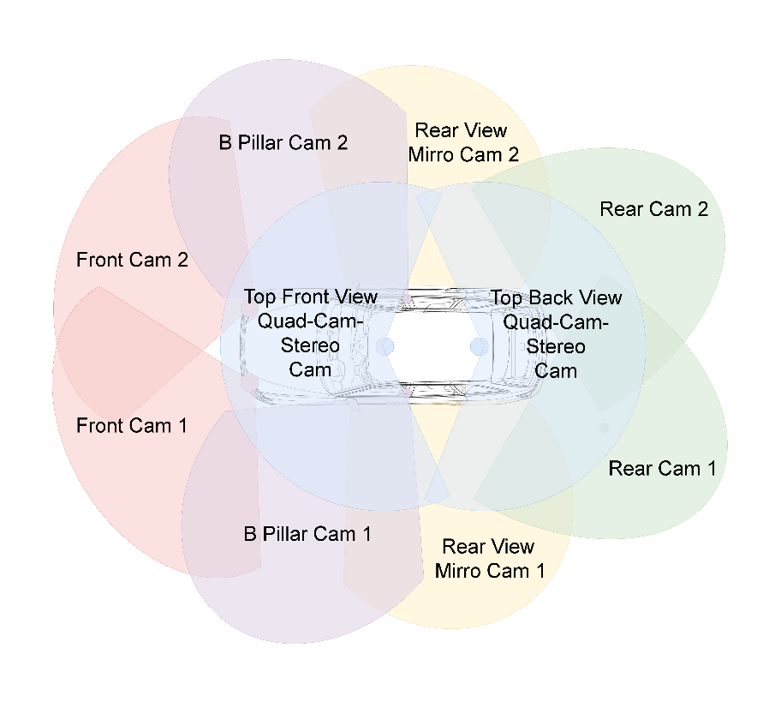

Figure 3: Camara View Area

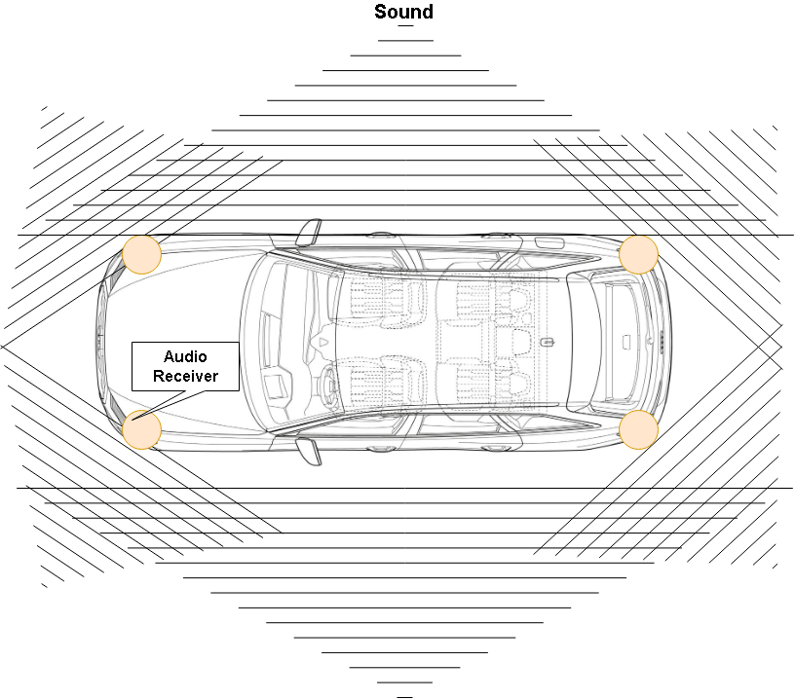

Figure 4: Audio Receiver

* 1. **Image Classification**

In order to achieve SLAM and make decisions which complete the whole system from perceiving to control the vehicle, neural networks were selected for this application.

The first neural network, RegNet proposed by Facebook, which is sophisticated at image classification [6]. RegNet structured design, based on quantized linear functions for stage widths and depths, enhances its image recognition capabilities, making it efficient and interpretable for real-time applications like autonomous driving. Its GPU utilization and predictable performance ensure reliable, fast image analysis for safe navigation and decision-making [6].

|  |  |
| --- | --- |
|  |  |
| 1. RegNet Block 1 | 1. RegNet block 2 |
| Figure 5: a) and b) display the RegNet block 1 and 2 | |

|  |  |
| --- | --- |
|  |  |
| 1. STEM Block of RegNet | 1. Head Block of RegNet |
| Figure 6: RegNet STEM Block | |

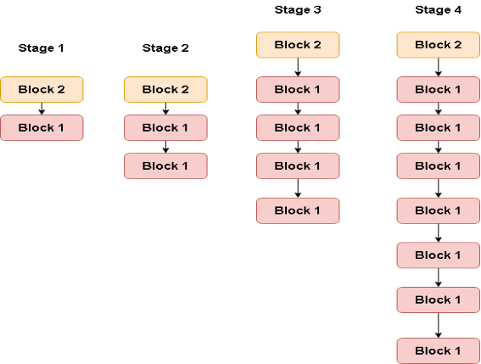

Figure 7: Stages of RegNet

|  |  |
| --- | --- |
|  |  |
| 1. Body structure of RegNet | 1. RegNet Overview |
| Figure 8: The body and overview structure of RegNet | |

Bi-directional Feature Pyramid Network (BiFPN) is introduced to further aid the object classification. BiFPN is the neural network structure that improves feature fusion and extraction by enhancing the process and transfer of multi-scale features through structured connectivity between layers [7]. It uses weighted feature to minimize information loss and maintain feature integrity, particularly aiming at distant objects. The biphasic connectivity and weighted fusion techniques, facilitates the handling of shallow and deep semantic features, strengthen detection performance in complex scenarios [8]. Figure 9 illustrates the overview concept structure of the network.

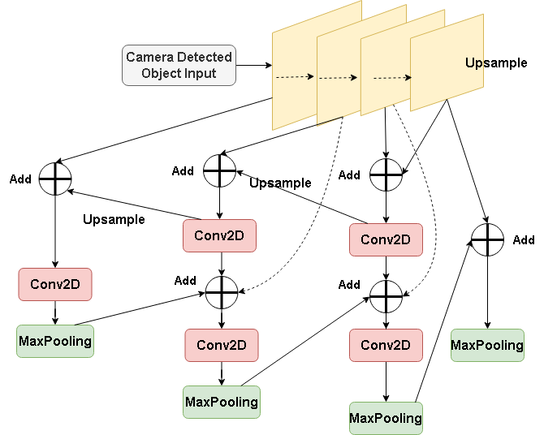

Figure 9：Bi-directional Feature Pyramid Network Concept Overview

The object detection framework consisting of RegNet and BiFPN, can handle various scenarios but faces different object types in traffic. To ensure maximum precision in image recognition, the spine of the network is branched into multiple sub-networks, with other possible differenct mechanisms and blocks adding into them, each fine-tuned to handle various object types. For example, the traffic light detection could be fine-tuned and then adding the structure of YOLO-V5 into the sub-network which had been proved through the work of Zhang et al [7]. Moreover, PANet's robust network architecture and processing capabilities make it ideal for complex visual tasks like lane detection, enhancing feature extraction, fusion, and classification accuracy [9]. Other fine adjustments or structure could also be put into sub-networks. Examples showed in Figure 10.

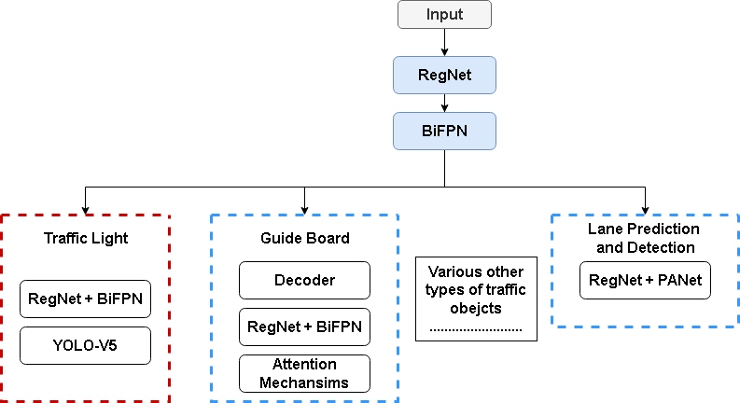

Figure 10: Combined Neural Network for object detection of auto-driving (RB-Block)

* 1. **SLAM Realization**

To achieve fully auto-driving, solely object detection cannot suffice as numbers of objects are beyond the dataset and object detection only finds the object but not clarifying its shape. And thus, following methods are added to enhance visual perception.

Bird’s Eye View (BEV) is crucial in autonomous driving system for providing top-down-view map which facilitates the perception of vehicle [10]. However, traditional projection is less reliable due to 2D information that has no details of surrounding 3D grid, that cannot be used for SLAM [11]. Therefore, an occupancy network (ONet) is added into the sensing system, transforming the 2D-BEV to 3D-BEV which simultaneously achieve SLAM in this case. ONet predicts 3D space occupancy, allowing extraction of 3D meshes from learned data [12]. This process enables the transformation of 2D-BEV into 3D scenes, calculated from images captured through cameras, thereby confirming 3D details of surroundings volumes, such as buildings, obstacles, pedestrians, etc., and provides precise localization and mapping. Figure 11 illustrates the transformation.

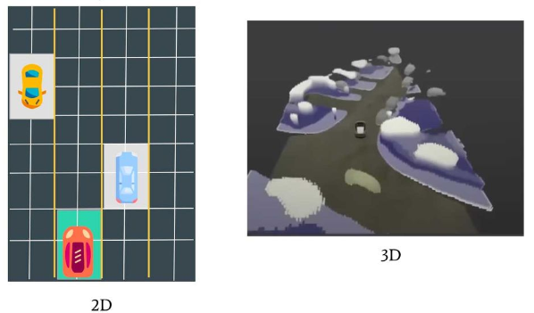

Figure 11: Examples of 2D-BEV to 3D-BEV(Occupancy Volume)[13]

Furthermore, 3D reconstruction is achieved through multi-angle images captured from two quad-cameras with a combined neural network of Neural Radiance Field (NeRF) and Depth-Estimation-Network (DEN). NeRF focuses on recreating free viewpoint 3D scenes, while DEN predicts the depth of each pixel within the scene [14]-[15]-[16]. The results from NeRF and DEN serve as both cross-validated data with 3D-BEV generated by occupancy network, ensuring accurate SLAM, and backup of the specific scene upload to cloud regularly. Figure 12 and Figure 13 demonstrate the effect.

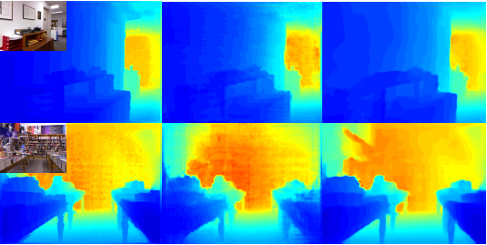

Figure 12: Pixel depth estimation, where the color of each pixel represents the distance from current camera [15]

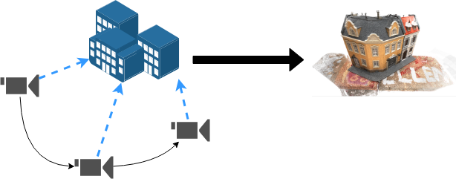

Figure 13: NeRF 3D Reconstruction Example

* 1. **Audio Components**

Besides visual computing, audio receiver takes the input audio and analyzes it through WaveResNet, enhancing autonomous vehicles' ability to identify vehicles in emergency by analyzing the sound and frequency of sirens or vehicle horn [17]. And thus, supports vision based autonomous driving. Figure 14 shows the logic.

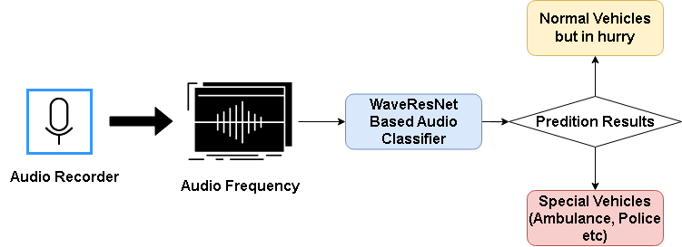

Figure 14: Audio Process within Sensing System

* 1. **Sensing System Integration**

Upon perceiving surroundings, receiving direct motion situation from IMU and combining the BDS coordinates or overall routes scheduling, vehicles make decisions to navigate themselves. This part will be controller by a transformer structured model that trained with millions of human driving behavior data. Transformer uses self-attention mechanisms to analyze integrated information from all sensing system and dynamically generate driving strategy to control vehicle [18]. Figure 15 illustrates the basic idea.

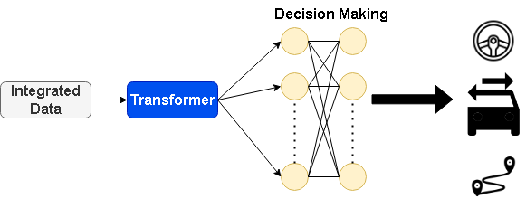

Figure 15: Transformer Decision Making

And by summarizing all above, Figure 16 displays the whole process from perception to control.

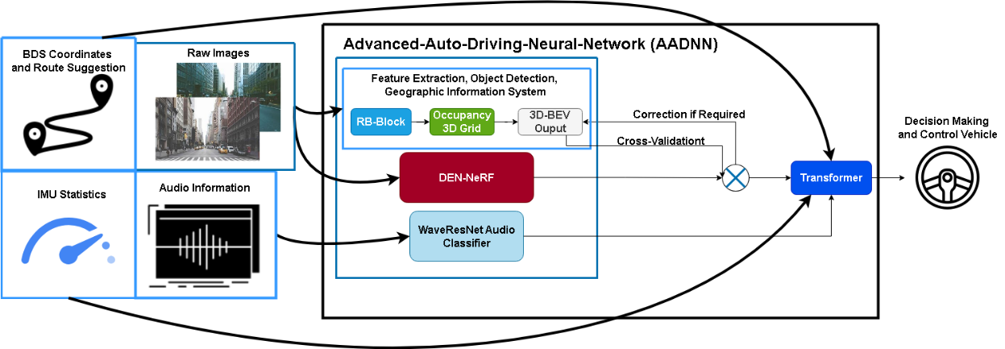

Figure 16: Overall Neural Network of Sensing System (AADNN)

## Cloud Solution (202018010212)

To reach level 5 autonomous driving, cloud solution plays another crucial part within this auto-driving system. In order to align with regulations and make this deployable, Alibaba Cloud is selected as the cloud solution provider [19]. It combines SaaS, PaaS and IaaS which makes it a proper Hyper Cloud. Details are provided in Figure 15 and 16.

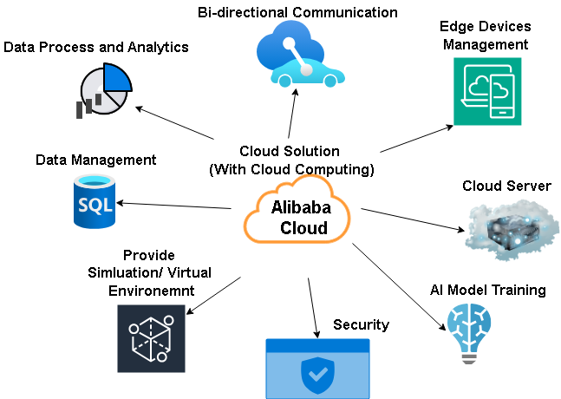

Figure 17: Cloud Solution Provides Services

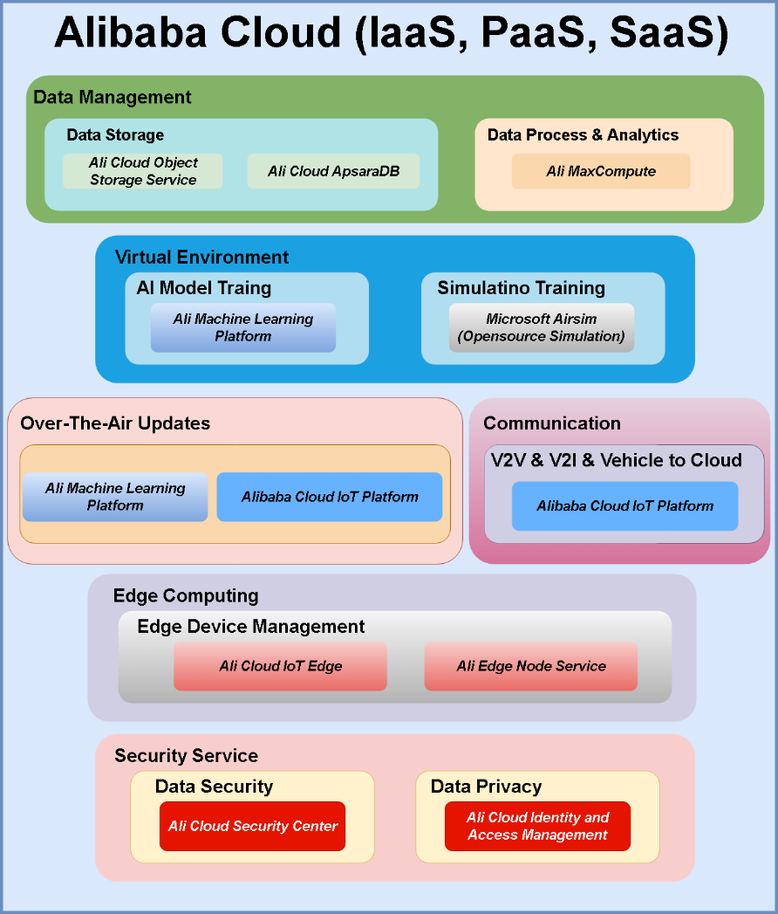

Figure 18: Cloud Solution Function Provider

* **Data Management:**

This part includes storage, processing and analytics. Long lasting data is stored in database server provided by Ali cloud, such as 3D map construction backup, datasets of driving patterns, objects, cyber-attack records. Ali also uses MaxCompute for real-time data processes and analysis.

* **Virtual Environment:**

The statistical training uses Ali machine learning, whereas simulation utilizes Microsoft Airsim, an opensource simulator built for autonomous vehicles development, allowing repeated, safe and cost friendly tests, deployable anywhere on a server. This facilitates AI driving algorithm development and fine adjustments.

* **OTA Updates:**

Ali Cloud platform of IoT and machine learning enable software updates including model, inner 3D reconstructed maps. Allowing autonomous vehicle operates on latest information.

* **Communication:**

Communication is categorized into edge devices and direct vehicle to cloud communication. In this case, Ali IoT platform manages millions of IoT devices, capable of assisting information exchange among all devices. Notably, cloud only participates in computing directly between vehicle to cloud communication, for instance, offers real-time traffic navigation suggestions.

It also takes part in managing edge devices communication session.

* **Edge Computing:**

The efficiency of timeless information exchange can be further improved through edge computing. In scenarios such as traffic accidents in short range where immediate response is required, vehicle and roadside infrastructures will be computation carrier that performs V2V, V2I communication within range for instant traffic rearrangement suggestions. These can be achieved through Ali ENS (Edge Node Services) and IoT Edge.

* **Data Security:**

Data protection privacy mainly points at ensuring integrity and authenticity during data sharing procedure between cloud and vehicle, containing user information, authorization etc. In this case, RSA encryption procedure, managed by Ali security center is applied. Furthermore, data security during V2I or V2V communication should be guaranteed while maintaining efficiency, and therefore access control, data encryption and identity authentication of vehicles is applied and managed through Ali cloud security services.

## Data Collection and Usage (202018010212)

Within this autonomous driving system, data are separated into two categories, dynamic and static data which are captured through sensing system and vehicle software, stored within cloud server.

1. **Dynamic Data**

Dynamic data primarily concentrates on behavioral data collected from driving. It forms a maneuver-based dataset containing video records of driving. For example, real-time movement patterns, driving behavior under various traffic flow, vehicle navigation record combining with audio behavior, changes among various driving conditions, including weather, area, or rush hours etc. [20].

1. **Static Data**

Static data represents information that is rather consistent over time, like 3D maps. It contains detailed 3D city reconstructions of buildings, bridges, and tunnels that captured by vehicles passed by during the cross validation with 3D-BEV calculations, and uploaded afterwards. Data also contains unique serial number of vehicle and BDS records structured the data. Figure 19 displays how data are collected.

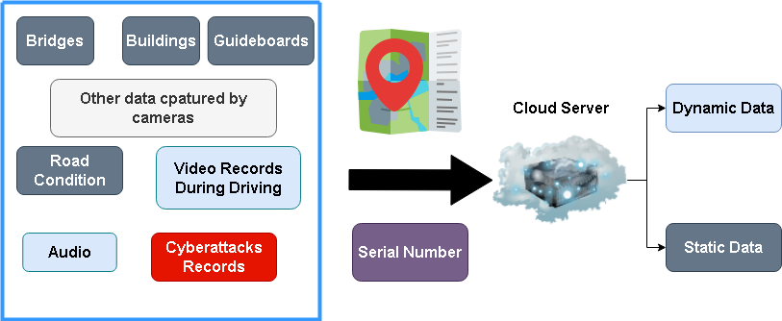

Figure 19: Unified Data Collection

1. **Data Transmission**

Since the amount of data is excessively huge and high likely repeated which made it falls in area of big data that requires MapReduce for efficient data collection. As mentioned, BDS coordinates records and serial number map the data transmitted from each vehicle. However, multiple vehicles pass through same locations leading to duplications in datasets. MapReduce assists aggregating them based on locations and decrease the overall data volume. Figure 20 displays the procedure.

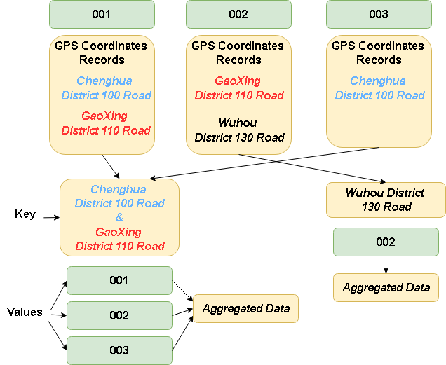

Figure 20: MapReduce Procedure for Data Aggregation

1. **Data Usage**

Other than the data collected aims at timely autonomous driving decisions making which processed within vehicle, data collected is mainly applied in two ways, auto-driving model training and software periodical updates.

First, model training operates within cloud server using Ali platform and a collaborative virtual environment for statistical training. Then it is tested on Airsim deployed on the server, where model navigates a virtual vehicle through various scenarios including different challenges on traffic. These processes extensively evaluate autonomous driving software prior to deployment [21].

Following these testing, the revised model is updated and delivered to automobiles via the cloud server. Figure 21 displays the example image of Airsim. Figure 22 and Figure 23 illustrate the training process.

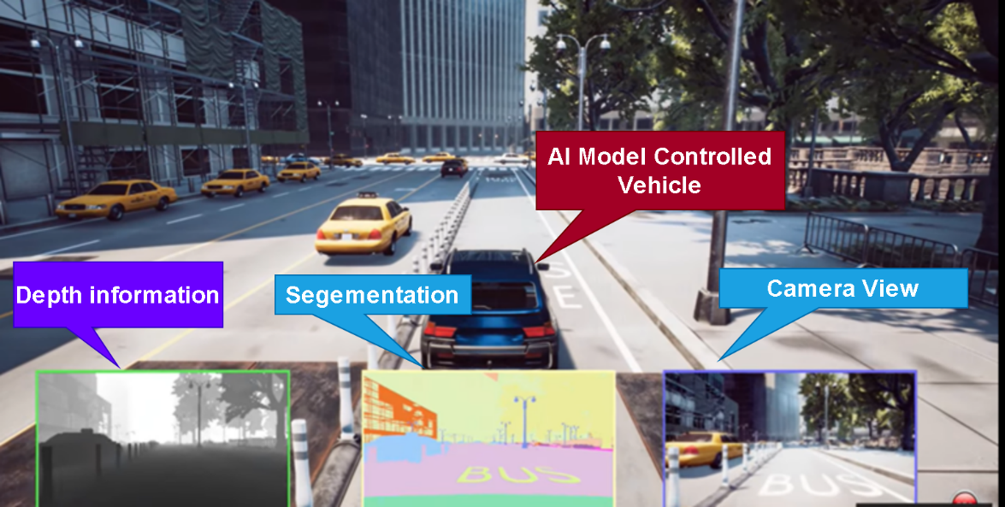

Figure 21: Airsim, opensource simulation provided by Microsoft (Built with Unreal 5 engine)

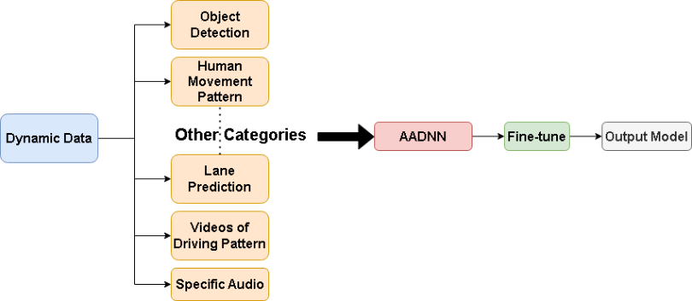

Figure 22: Model Statistical Training Process

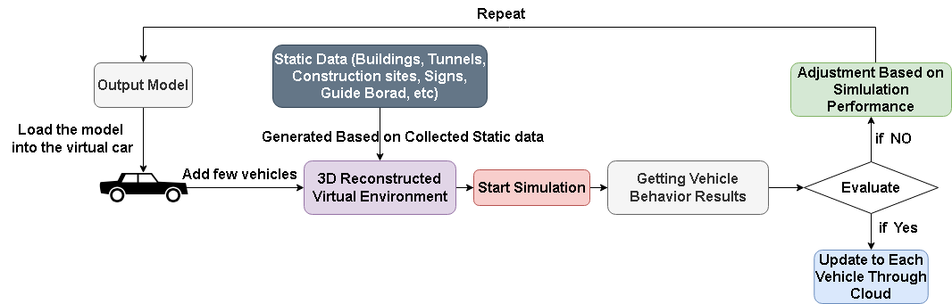

Figure 23: Simulation Basic Logic

Besides simulation scene generation, static data is also used for vehicle inner map 3D reconstruction serves as the extension of satellite maps and backup map in dim light scenarios. BDS location history maps the 3D models with corresponding 2D or 2.5D satellite maps, serial numbers eliminate duplication with MapReduce, resulting in accurate reproduction of actual 3D maps. And the map is regularly delivered to vehicle. Figure 24 provides the process.

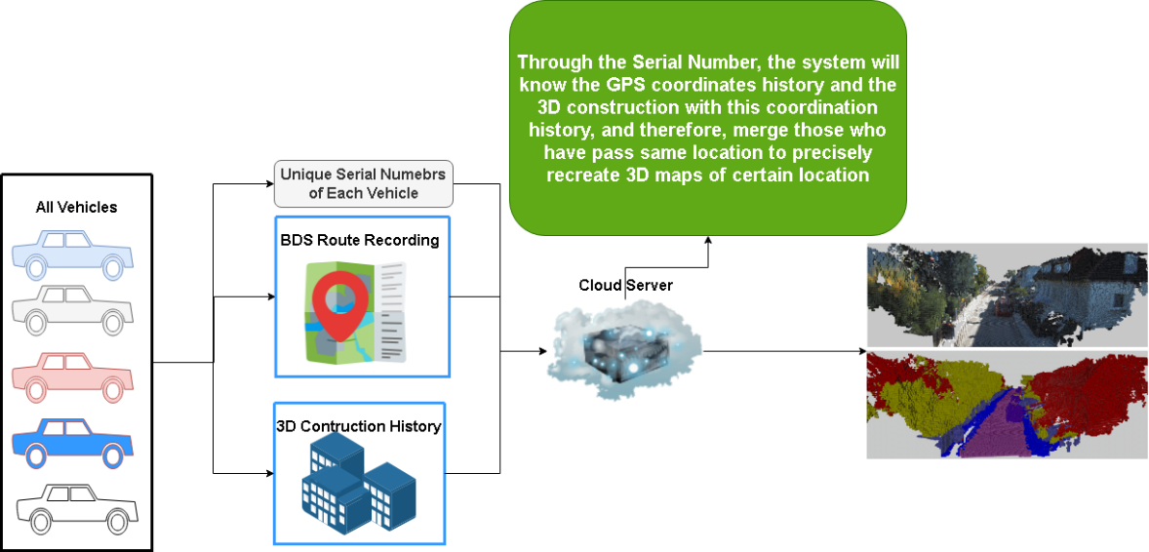

Figure 24: Precise Construction based on specific information of vehicle

## Roadside Units (RSU) (202018010110)

Perception systems, while effective in detecting surroundings, struggle with distant or obstructed signs, necessitating the installation of Roadside Units (RSUs) to improve timely decision-making.

1. **RSU Storage & Communication Protocol**

Roadside Surveillance Units (RSUs) are communication devices used for data exchange, collection, transmission, and broadcasting. They include intelligent traffic signals, electronic road signs, VMS, environmental monitoring equipment, and traffic surveillance cameras. Information exchange helps provide future traffic conditions, enhancing planning efficiency.

Roadside Units (RSUs) use local data storage to process traffic information and vehicle transit records, reducing latency and bandwidth requirements. Equipped with high-speed cache DRAM and SSDs, RSUs can transfer data to the cloud for analysis during idle times. A protocol is needed for reliable information exchange between RSUs and vehicles.

Research indicates that the two protocols currently in use, IEEE 802.11p (for DSRC) and 3GPP (for C-V2X), have undergone significant changes following the Federal Communications Commission (FCC) official vote to allocate the 5.9GHz band (5.850-5.925GHz) for Wi-Fi and C-V2X use [22]. Specifically, the upper 30MHz band (5.895-5.925 GHz) has been allocated to C-V2X. This means that DSRC has been completely abandoned, as C-V2X offers faster speeds and higher reliability.

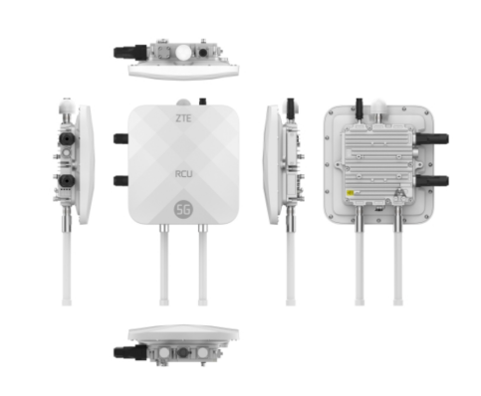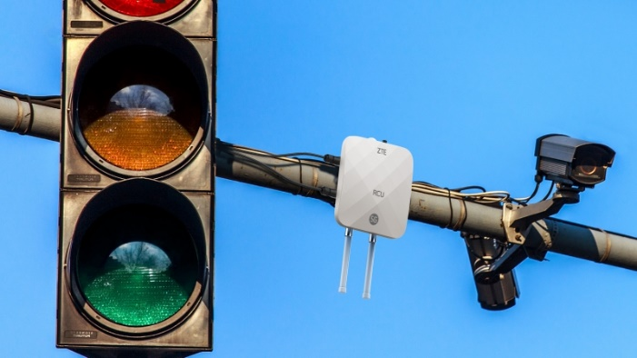

Figure 25**:** RSU device of ZTE [23]

ZTE's 5G RSU device in Figure 25, featuring full-band Uu and PC5 communication, connects up to 16 video channels, 8-millimeter-wave radar channels, and 2 lidar channels with a power consumption below 50W, making it ideal for the self-driving system.

## V2V & V2I Communication (202018010110)

The authors [24] integrate 5G and C-V2X technologies, demonstrating that compared to DSRC, these technologies enable data exchange over greater distances and can transmit more data and information. This is particularly suited for the self-driving domain, which requires large-scale data transmission.

C-V2X provides two communication modes: direct communication mode (PC5) and network communication mode (Uu). The PC5 direct communication mode allows for direct communication between vehicles and RSUs without relying on cellular network infrastructure. This mode is typically used in low-latency, high-reliability scenarios. Vehicles and RSUs establish a direct connection through the PC5 interface, perform authentication, negotiate communication parameters, and then proceed with data exchange.

1. **Road Network**

Simulation devices and genetic algorithms are used to optimize RSU placement in areas without RSUs, ensuring comprehensive coverage and redundancy by covering each vehicle with at least one RSU and using two RSUs for simultaneous data recording.

In Figure 26, the road traffic networks in different cities vary, requiring RSU deployment to be tailored to actual conditions to ensure coverage and service quality. The following mentions two methods to address this issue.

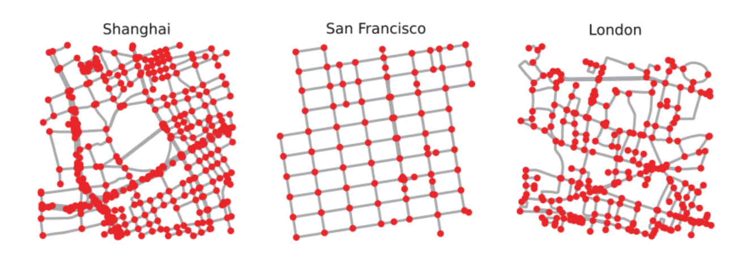

Figure 26**:** Road network diagram [25]

There are two methods for optimizing communication between RSUs: using network topology optimization algorithms, such as minimum spanning tree algorithms or distributed routing algorithms, to optimize communication paths between RSUs, ensuring connectivity and stability and minimizing communication hops during RSU deployment to reduce relay nodes in communication paths, thereby enhancing communication efficiency and reliability.

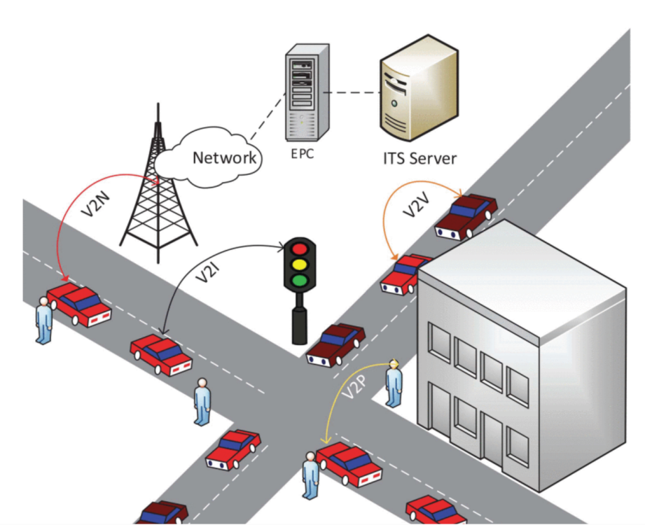

Figure 27**:** V2X model [26]

1. **C-V2X Protocol**

Not only is this applicable to interactions between RSUs and vehicles, but also to V2V and V2I communication modes. These can be accomplished using the C-V2X protocol, with vehicles using onboard units (OBUs) to interact with RSUs. This forms a vast vehicular ad hoc network, enabling direct communication between vehicles, including the exchange of location information and dynamic data such as speed and acceleration from IMU units. This is particularly beneficial in scenarios involving intersections and roundabouts. Vehicles can use the C-V2X protocol to interact with traffic signals before entering such areas, obtaining signal status and route planning information to adjust their states in real-time.

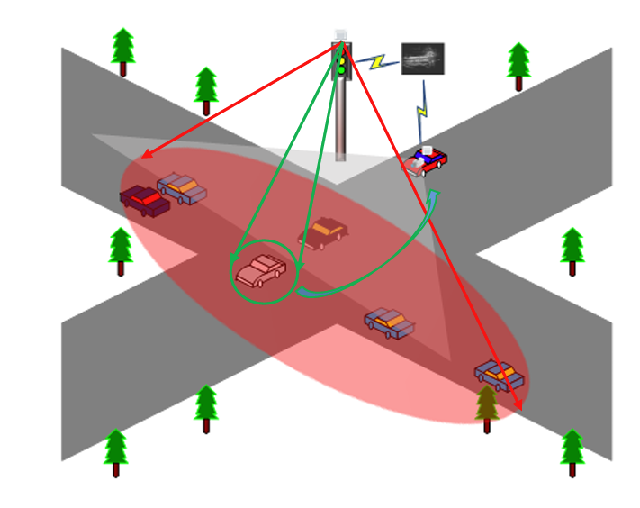

Figure 28**:** Perception for Autonomous Vehicles at Intersections[27]

## Data Security (202018010110)

1. **Data Encryption (Vehicle to Cloud)**

For data security, as mentioned in cloud solution, vehicle to cloud uses RSA as data encryption algorithm, it is an asymmetrical encryption algorithm, prior for encryption key exchange and digital signature, ensuring data integrity and authenticity [28].

First, Ali cloud manages and generates public and private encryption key by choosing to big prime numbers and calculate their multiplication. Then get the result of Euler function, an exponent of public key is chosen, normally could be 65573 for it balance security and computational resource management. Then the exponent of private key is calculated as well, there they possess public key and private key. When vehicle transmits data to cloud, it askes cloud for public key to encrypt plaintext data, then send the ciphertext to Ali cloud where encrypted text will be decrypted and regenerate plaintext. To keep integrity and authenticity, digital signature is assigned based on private key. SHA-256 could be applied in this case where cloud calculate the hash value and verifies with the hash value from vehicle, thereby ensuring data integrity. Equations are provided below

|  |  |
| --- | --- |
| $$n = p ∗ q$$ | (1) |
| $$ϕ(n)=(p−1)×(q−1)$$ | (2) |
| $$e ∗ d ≡ 1 mod ϕ(n)$$ | (3) |
| public key *(e, n)* private key *(d, n)* | (4) |
| Vehicle: $C = M^{e} mod n$ | (5) |
| Cloud: $M = C^{d} mod n$ | (6) |

1. **Data Encryption (V2V & V2I)**

As for data encryption between among vehicles and infrastructures, a more computation efficient but secure algorithm, AES-CBC is applied [29]. For example, vehicle A uses key exchange protocol such as ECDH for generation of share symmetric key. Then vehicle A generates an IV for encryption. Vehicle A uses IV and key to encrypt plaintext and transmit the cipher text to vehicle B where cipher text will be decrypted into plaintext with the IV and symmetric key. Following shows the Encryption procedure:

|  |  |
| --- | --- |
| $$Generation: IV \& Key$$ | (7) |
| $$M = M_{1}, M_{2},..... M_{n}$$ | (8) |
| $$C_{1} = AES_Encrypt (K, M1 ⊕ IV)$$ | (9) |
| $$C_{i} = AES_Encrypt (K,M_{i} ⊕ C_{i − 1} )$$ | (10) |
| $$C = ( C_{1}, C_{2}, C_{3}....C_{n})$$ | (11) |

For the purpose of ensuring data integrity and authenticity, both V2I, V2V, V2Cloud apply digital signature for data that ought to be transmitted. In this case, SHA-256 is applied. The sender gets a message digest H(M) calculated from data M by SHA-256, and assign a signature S then transmit both M and S to receiver. Receiver generates a digest H(M) from M then decrypts S using sender’s public key. If both digests match, data integrity and authenticity are ensured.

|  |  |
| --- | --- |
| H(M)1 = SHA-256(M) | (12) |
| S= H(M)d mod n | (13) |
| H(M)2 = Se mod n | (14) |
| Check: H(M)2 = H(M)1 | (15) |

1. **Signature and Anomaly Based Threats Detection**

Building on the TLS/SSL and digital certificates of the C-V2X protocol, a method based on signatures and anomaly detection is proposed to identify threats.

TLS/SSL protocols and digital certificates provide information confidentiality during transmission, but cannot defend against active and zero-day attacks. Signatures and anomaly detection offer an effective defense, marking vulnerabilities and allowing detection systems to download corresponding signatures from the cloud. However, this method relies on timely updating and cannot predict recent attacks like those published by CVE and TALOS [30]-[31].

To address this issue, anomaly detection methods can be used as a supplementary means of identification. Anomaly detection primarily involves training models using intrusion datasets that exhibit attack characteristics, thereby learning the inherent behaviors of attacks for identification purposes. Common datasets include NSL-KDD [32], UNSW-NB15 [33], and CICIDS2017 [34]. By selecting models such as Random Forest, training it on datasets in the cloud, and deploying the trained models to vehicles, the capability to detect zero-day attacks can be achieved.

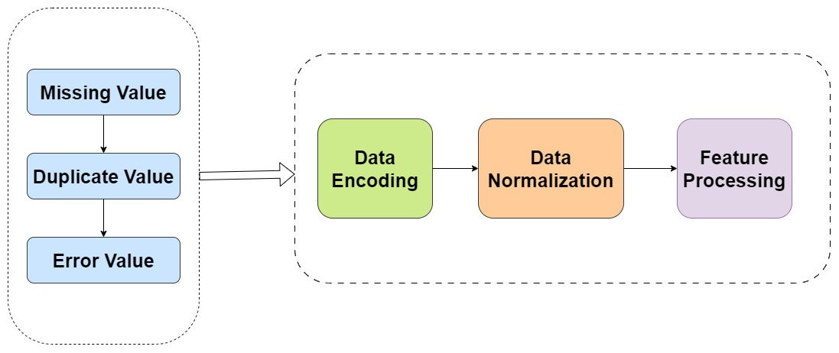

Figure 29: Data preprocessing

After obtaining the corresponding dataset, it is necessary to preprocess the data. As shown in Figure 29, this includes imputing or deleting missing values, redundant values, and outliers in the data. Additionally, One-Hot encoding [35] is used to convert categorical features into numerical values to facilitate model training. Next, the processed data is standardized to maintain the characteristics of the data distribution. Finally, feature selection is performed to identify features that are useful for the model, thereby reducing the size of the dataset and improving the efficiency of model training.

As shown in the Figure 30, the random forest model aggregates the results of multiple decision trees through a voting mechanism, observing the frequency with which each attack sample is predicted to belong to various categories. The sample is then classified into the category with the highest vote count. This voting mechanism significantly enhances the model's robustness and predictive capability, allowing it to make more accurate predictions.

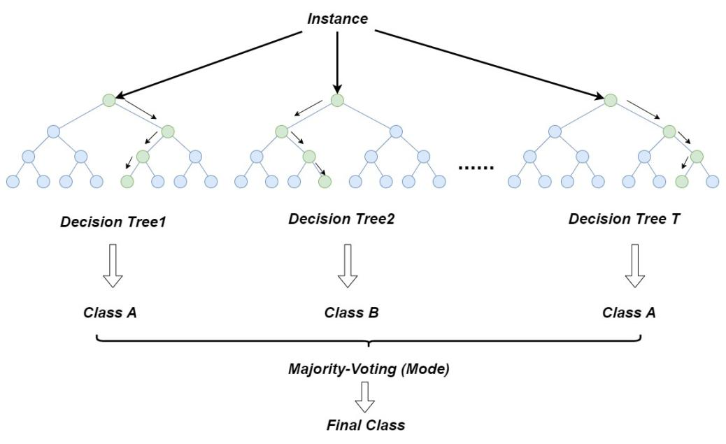

Figure 30**:** Random Forest

In Figure 31, all the risk prediction information mentioned above will be recorded in real-time in the vehicle's database and transmitted to the cloud through the C-V2X Uu interface during idle IO periods. The cloud will retrain on these new risky data and incorporate them into simulation training. Once the model is trained, it will be redeployed to the vehicle through cloud and edge computing, enabling the vehicle to gain latest security features.

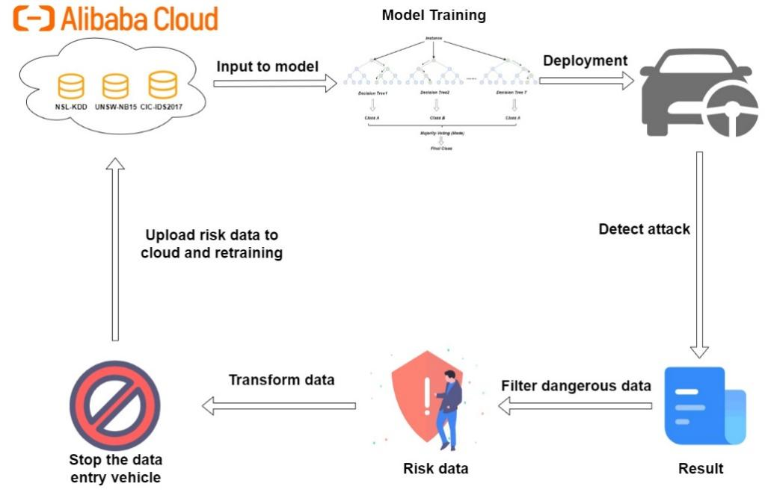

Figure 31**:** Overall security system architecture

## Conclusion (Joint Section)

Through the design of the report, it is assumable that based on the accuracy of the sensing system and collaboration of Ali cloud solution with vehicle network aiding to the self-driving system, level 5 an autonomy of vehicle navigation could be viable. To ensure, the safety issue of the highly autonomous vehicle system data encryption algorithm is integrated with the function provided by Ali cloud which facilitates the secure development of self-driving system.

However, there are numbers of aspects that did not take into account, such as vehicle sensing systems might be inaccurate since neural network lies opaque which encompasses uncertainty occasionally, and by intimating and expanding human driving patterns it could also possess the drawbacks of human drivers. As for communication among vehicles and infrastructures, the efficiency and stability of communication session is not guaranteed, for instance, during extreme traffic flow, it could overwhelm the local computing of vehicle. And data security should also take encryption and decryption speed into consideration allowing timely and secure data transmission.

## Work Management (Albert 202018010212, Darryl 202018010110)

|  |  |  |
| --- | --- | --- |
| **Working Contents** | **Detail** | **Participators** |
| **Research in autonomous driving technologies** | Looking for existing autonomous vehicles | Albert, |
| Overall analysis on Tesla, Waymo, Baidu, Huawei and Xiaomi | Albert |
| Collecting explanation of videos, blogs on popular autonomous driving | Albert, Darryl |
| **Introduction**  **(Joint)** | Providing overview of the report and organize ideas | Albert, Darryl |
| **Sensing system Designation**  **(Mainly: Albert)** | Establish the idea of mimic and improve human driving | Albert |
| Adding audio by intimating human driving | Albert |
| Adding thermal and Infrared for addressing drawbacks of vision-based system | Albert, Darryl |
| Suggestion of IMU for direct motion detect | Darryl, Albert |
| **Cloud Solution Selecting**  **(Mainly: Albert)** | Deciding the standard to refer to for selection | Albert, Darryl |
| Select the basic function of cloud solution | Albert |
| Fine adjustments for cloud functions | Albert Darryl |
| Integrating the security, communication strategy and protocol among them | Darryl, Albert |
| **Data Collection & Usage**  **(Mainly: Albert)** | Defining the content of data | Albert |
| Data collection categorization | Albert |
| Data usage | Albert, Darryl |
| **Roadside Infrastructures Units**  **(Mainly: Darryl)** | Research for RSU Devices | Darryl |
| Select protocol based on Comparison analysis on C-V2X and DSRC | Darryl |
| **V2V & V2I Communication**  **(Mainly: Darryl)** | RSU deployment location selection | Darryl, Albert |
| V2V & V2I communication protocol selection | Darryl |
| Vehicle network operation status in intersections | Darryl |
| **Data Security**  **(Mainly: Darryl)** | Data security transmission protocol selection (TLS /SSL) | Darryl |
| Data encryption and digital signature for data integrity and authentication  (RSA & AES-CBC) | Albert, Darryl |
| Threats detection using signature and anomaly of system | Darryl |
| **Conclusion**  **(Joint)** | Giving overall reflections and find out limitations about the design | Albert, Darryl |
| **Overall** | Albert | 1800 Words |
| Darryl | 1500 Words |

Table 2: Work Management

**Reference**

[1] K. Rana, G. Gupta, P. Vaidya, and M. Khari, “The perception systems used in fully automated vehicles: a comparative analysis,” *Multimed. Tools Appl.*, Apr. 2023, doi: 10.1007/s11042-023-15090-w.

[2] Y. Huang, H. Zhang, K. Guo, J. Li, G. Xu, and Z. Chen, “Density-Based Vehicle Detection Approach for Automotive Millimeter-Wave Radar,” in *2020 IEEE 3rd International Conference on Electronic Information and Communication Technology (ICEICT)*, Nov. 2020, pp. 534–537. doi: 10.1109/ICEICT51264.2020.9334238.

[3] L. Dai, Z. Zhang, and H. Xu, “Roadside Edge Sensed and Fused Three-dimensional Localization using Camera and LiDAR,” in *2022 7th International Conference on Image, Vision and Computing (ICIVC)*, Xi’an, China: IEEE, Jul. 2022, pp. 762–766. doi: 10.1109/ICIVC55077.2022.9886834.

[4] K. Hisatomi *et al.*, “Depth Estimation Using an Infrared Dot Projector and an Infrared Color Stereo Camera,” *IEEE Trans. Circuits Syst. Video Technol.*, vol. 27, no. 10, pp. 2086–2097, Oct. 2017, doi: 10.1109/TCSVT.2016.2555678.

[5] J. D. Choi and M. Y. Kim, “A Sensor Fusion System with Thermal Infrared Camera and LiDAR for Autonomous Vehicles: Its Calibration and Application,” in *2021 Twelfth International Conference on Ubiquitous and Future Networks (ICUFN)*, Jeju Island, Korea, Republic of: IEEE, Aug. 2021, pp. 361–365. doi: 10.1109/ICUFN49451.2021.9528609.

[6] I. Radosavovic, R. P. Kosaraju, R. Girshick, K. He, and P. Dollar, “Designing Network Design Spaces,” in *2020 IEEE/CVF Conference on Computer Vision and Pattern Recognition (CVPR)*, Seattle, WA, USA: IEEE, Jun. 2020, pp. 10425–10433. doi: 10.1109/CVPR42600.2020.01044.

[7] X. Zhang, S. Mo, and Z. Wan, “Traffic sign detection algorithm based on YOLOv5 combined with BIFPN and attention mechanism,” in *2023 IEEE 7th Information Technology and Mechatronics Engineering Conference (ITOEC)*, Chongqing, China: IEEE, Sep. 2023, pp. 966–970. doi: 10.1109/ITOEC57671.2023.10291927.

[8] Y. Guo, S. Chen, R. Zhan, W. Wang, and J. Zhang, “SAR Ship Detection Based on YOLOv5 Using CBAM and BiFPN,” in *IGARSS 2022 - 2022 IEEE International Geoscience and Remote Sensing Symposium*, Kuala Lumpur, Malaysia: IEEE, Jul. 2022, pp. 2147–2150. doi: 10.1109/IGARSS46834.2022.9884180.

[9] Y. Ma, “PANet: parallel attention network for remote sensing image semantic segmentation | VDE Conference Publication | IEEE Xplore.” Accessed: May 03, 2024. [Online]. Available: https://ieeexplore.ieee.org/document/9738937

[10] H. Rashed, M. Essam, M. Mohamed, A. Ei Sallab, and S. Yogamani, “BEV-MODNet: Monocular Camera based Bird’s Eye View Moving Object Detection for Autonomous Driving,” in *2021 IEEE International Intelligent Transportation Systems Conference (ITSC)*, Indianapolis, IN, USA: IEEE, Sep. 2021, pp. 1503–1508. doi: 10.1109/ITSC48978.2021.9564667.

[11] H. Fu, H. Xue, and R. Ren, “Fast Implementation of 3D Occupancy Grid for Autonomous Driving,” in *2020 12th International Conference on Intelligent Human-Machine Systems and Cybernetics (IHMSC)*, Hangzhou, China: IEEE, Aug. 2020, pp. 217–220. doi: 10.1109/IHMSC49165.2020.10127.

[12] L. Mescheder, M. Oechsle, M. Niemeyer, S. Nowozin, and A. Geiger, “Occupancy Networks: Learning 3D Reconstruction in Function Space,” in *2019 IEEE/CVF Conference on Computer Vision and Pattern Recognition (CVPR)*, Long Beach, CA, USA: IEEE, Jun. 2019, pp. 4455–4465. doi: 10.1109/CVPR.2019.00459.

[13] “A Look at Tesla’s Occupancy Networks,” Welcome to The Library! Accessed: May 03, 2024. [Online]. Available: https://www.thinkautonomous.ai/blog/occupancy-networks/

[14] H. Aoki and T. Yamanaka, “Improving Nerf with Height Data for Utilization of GIS Data,” in *2023 IEEE International Conference on Image Processing (ICIP)*, Kuala Lumpur, Malaysia: IEEE, Oct. 2023, pp. 935–939. doi: 10.1109/ICIP49359.2023.10222573.

[15] X. Duan, X. Ye, Y. Li, and H. Li, “High Quality Depth Estimation from Monocular Images Based on Depth Prediction and Enhancement Sub-Networks,” in *2018 IEEE International Conference on Multimedia and Expo (ICME)*, San Diego, CA: IEEE, Jul. 2018, pp. 1–6. doi: 10.1109/ICME.2018.8486539.

[16] K. Gao, Y. Gao, H. He, D. Lu, L. Xu, and J. Li, “NeRF: Neural Radiance Field in 3D Vision, A Comprehensive Review.” arXiv, Nov. 30, 2023. Accessed: May 04, 2024. [Online]. Available: http://arxiv.org/abs/2210.00379

[17] V.-T. Tran and W.-H. Tsai, “Audio-Vision Emergency Vehicle Detection,” *IEEE Sens. J.*, vol. 21, no. 24, pp. 27905–27917, Dec. 2021, doi: 10.1109/JSEN.2021.3127893.

[18] W. Fu, Y. Li, Z. Ye, and Q. Liu, “Decision Making for Autonomous Driving Via Multimodal Transformer and Deep Reinforcement Learning,” in *2022 IEEE International Conference on Real-time Computing and Robotics (RCAR)*, Guiyang, China: IEEE, Jul. 2022, pp. 481–486. doi: 10.1109/RCAR54675.2022.9872180.

[19] “Alibaba Cloud Integrated Solution for Autonomous Driving: Breaking through Technology Bottlenecks,” Alibaba Cloud Community. Accessed: May 17, 2024. [Online]. Available: https://www.alibabacloud.com/blog/alibaba-cloud-integrated-solution-for-autonomous-driving-breaking-through-technology-bottlenecks_596738

[20] B. Toghi *et al.*, “A Maneuver-based Urban Driving Dataset and Model for Cooperative Vehicle Applications,” in *2020 IEEE 3rd Connected and Automated Vehicles Symposium (CAVS)*, Victoria, BC, Canada: IEEE, Nov. 2020, pp. 1–6. doi:

10.1109/CAVS51000.2020.9334665.

[21] B. Kim and E. Kang, “Toward Large-Scale Test for Certifying Autonomous Driving Software in Collaborative Virtual Environment,” *IEEE Access*, vol. 11, pp. 72641–72654, 2023, doi: 10.1109/ACCESS.2023.3295500.

[22] “FCC Modernizes 5.9 GHz Band to Improve Wi-Fi and Automotive Safety | Federal Communications Commission.” Accessed: May 17, 2024. [Online]. Available: https://www.fcc.gov/document/fcc-modernizes-59-ghz-band-improve-wi-fi-and-automotive-safety

[23] “ZTE officially released the industry’s first vehicle-road coordination and roadside computing integrated product.” Accessed: May 17, 2024. [Online]. Available: https://www.zte.com.cn/content/zte-site/www-zte-com-cn/china/about/news/20230629c4

[24] C. R. Storck and F. Duarte-Figueiredo, “A Survey of 5G Technology Evolution, Standards, and Infrastructure Associated With Vehicle-to-Everything Communications by Internet of Vehicles,” *IEEE Access*, vol. 8, pp. 117593–117614, 2020, doi:

10.1109/ACCESS.2020.3004779.

[25] B. Liang, W. Lu, and B. Ran, “Deploying Roadside Unit Efficiently in VANETs: A Multi-Objective Delay-Based Optimization Strategy Using Lagrangian Relaxation,” *IEEE Trans. Intell. Transp. Syst.*, vol. 25, no. 2, Art. no. 2, Feb. 2024, doi:

10.1109/TITS.2023.3315213.

[26] S. Gyawali, S. Xu, Y. Qian, and R. Q. Hu, “Challenges and Solutions for Cellular Based V2X Communications,” *IEEE Commun. Surv. Tutor.*, vol. 23, no. 1, Art. no. 1, 2021, doi: 10.1109/COMST.2020.3029723.

[27] X. Duan, H. Jiang, D. Tian, T. Zou, J. Zhou, and Y. Cao, “V2I based environment perception for autonomous vehicles at intersections,” *China Commun.*, vol. 18, no. 7, Art. no. 7, Jul. 2021, doi: 10.23919/JCC.2021.07.001.

[28] X. Huang and W. Wang, “A Novel and Efficient Design for an RSA Cryptosystem With a Very Large Key Size,” *IEEE Trans. Circuits Syst. II Express Briefs*, vol. 62, no. 10, pp. 972–976, Oct. 2015, doi: 10.1109/TCSII.2015.2458033.

[29] M. E. Hameed, M. M. Ibrahim, N. A. Manap, and A. A. Mohammed, “A lossless compression and encryption mechanism for remote monitoring of ECG data using Huffman coding and CBC-AES,” *Future Gener. Comput. Syst.*, vol. 111, pp. 829–840, Oct. 2020, doi: 10.1016/j.future.2019.10.010.

[30] “CVE - CVE.” Accessed: May 17, 2024. [Online]. Available: https://cve.mitre.org/

[31] “TALOS-2023-1887 || Cisco Talos Intelligence Group - Comprehensive Threat Intelligence.” Accessed: May 17, 2024. [Online]. Available:

https://talosintelligence.com/vulnerability_reports/TALOS-2023-1887

[32] “NSL-KDD | Datasets | Research | Canadian Institute for Cybersecurity | UNB.” Accessed: Apr. 15, 2024. [Online]. Available: https://www.unb.ca/cic/datasets/nsl.html

[33] N. Moustafa and J. Slay, “UNSW-NB15: a comprehensive data set for network intrusion detection systems (UNSW-NB15 network data set),” in *2015 Military Communications and Information Systems Conference (MilCIS)*, Nov. 2015, pp. 1–6. doi:

10.1109/MilCIS.2015.7348942.

[34] “IDS 2017 | Datasets | Research | Canadian Institute for Cybersecurity | UNB.” Accessed: May 17, 2024. [Online]. Available: https://www.unb.ca/cic/datasets/ids-2017.html

[35] “sklearn.preprocessing.OneHotEncoder,” scikit-learn. Accessed: Apr. 18, 2024. [Online]. Available: https://scikit-learn/stable/modules/generated/sklearn.preprocessing.OneHotEncoder.html